Chapter 10:
Process Control Studio

10.1 Getting Started with Process Control Studio
Process Control Studio is designed to achieve the principle of WYSIWYG (What You See is What You Get). 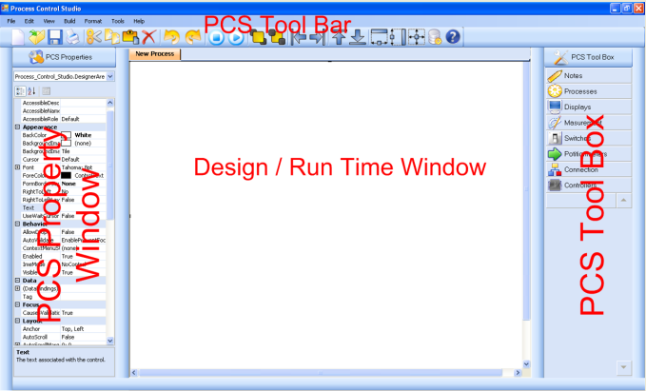

Process Control Studio is Consists of:

10.1.1 ToolBox
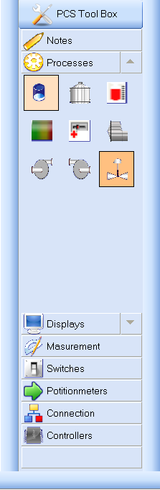
- Consists of number of tabs; each tab consists of number of components.
- It includes all components used in designing the process.
- Expands the members of a group by clicking the name of the group.
- There is a tool tip that appears when mouse moves over every component to tell you the name of this component.
- Control engineer can “drag and drop” controls onto a design form
- Control engineer can change tool box icon by right click inside it and chose View > List.
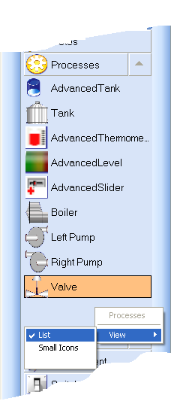

- Notes Tab  - It helps the user to add notes, and labels on the design area | 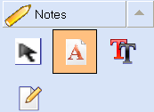
- Process Tab  - This group is considered as the backbone of any industrial process.  - Control should be applied mostly on the components of this group | 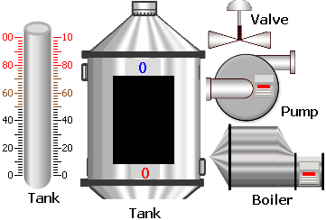
- Displays Tab  - It is used mainly for displaying output data or response of the process to be observable by the operator.  - Data displayed in the component of this type occurs in real time.  - Properties of displays can be easily modified to change color, data type, etc. | 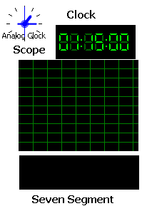
- Measurement Tab  - Each component of this type is responsible for measuring a certain type of physical quantity.  - Circular gauges & meters can be used for pressure reading while thermometers are used in thermal processes.  - Maximum and minimum values and measurement units can be modified for gaining the highest accuracy. | 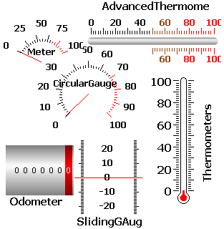
- Switches Tab  - Different types of switches can be used by the designer.  - On/Off switch & multi-position switch can be used In process. | 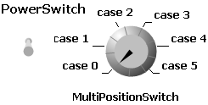
- Potentiometer Tab  - Potentiometer is mainly used for varying a certain parameter in the system.  - It can also act as an output display.  - Setting potentiometer range can be easily handled from the property grid of the software. | 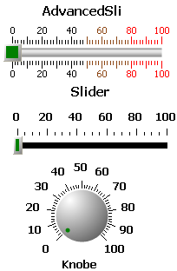
- Controller Tab  - There are two types of controllers to help the designer to control the required process.  - ON-OFF & PID controllers are widely used in industrial process.  - Required tuning parameters for both controllers can be set from the property grid or during run-time.  - Set point, proportional gain, integral gain and differential gain are the required parameters for tuning the PID Controller.  - Set point and neutral zone are the required parameters for the ON-OFF controller. | 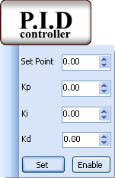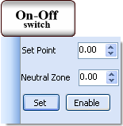

10.1.2 Property Window
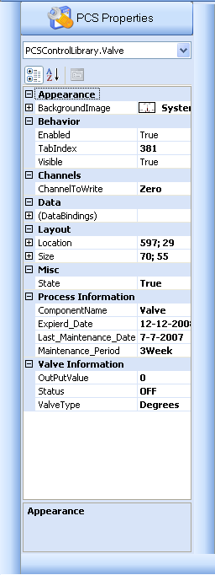
The second window in Process Control Studio is the Property Widow which allows manipulation of the properties for a form or control component by:
- Setting all values of any controller or component.
- Setting any general property for any control
- Size ,Position
- Name , Type, Color
- Expired Date
- Last Maintenance Date
- Maintenance Period
- Channel to Read or Write
  - Setting a specific property of some component like:
- Set Point, Kp, Ki, Kd for PID Controller
- Set Point , Neutral Zone for ON-OFF Controller
  - Any Change in any property or value will be
shown in the Design area.
- The bottom of the Properties window contains a description of the selected property.
- The left column of the Properties window shows the properties of the control the right column displays their current values.
- The Properties window allows programmers to modify controls visually.

10.1.3 Design Window
- This is the main area of designing a process.
- Any connections like pipes or wires shall be implemented in the design area.
- As shown the user can open more than one design window at the same time
and can switch between them using tabs.
- Designing the process is the control engineer’s responsibility ,setting the channel
of the coming data is handled also by the engineer.
- By using the control components from PCS Toolbox a process can be built.
- Designing the process means creating a model for a real process on the program,
connecting them, and setting their states, initializations and properties exactly as it is in the real process.
  - The better design model the better and easier monitoring and controlling becomes.
  - The design model can be modified at any time by an engineer after stopping the process.
  - As shown, the background color of design window is white.
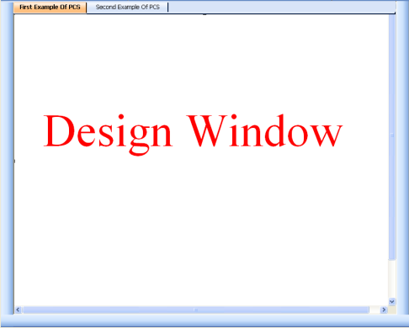

10.1.4 Process Run Time Window
- Perform Connecting & Disconnecting Events with the industrial process.
- Communicate with the process (sending & receiving data and commands).
- Take control action by changing parameters of the controllers (PID and ON-OFF Controller.
- Plot process response.
- Show History for each component in the process.
- Monitoring and controlling process in real-time.
- Monitoring and controlling more than one process at the same time using multiple tabs.
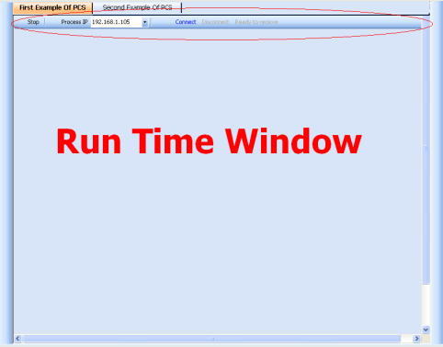

10.1.4.1 Runtime Toolbar
- Choose IP address of the local controller
- Connect is used to connect to the process and start sending and receiving data.
- Stop is used to stop receiving data from process but not to disconnect from the process.
- Disconnect is used to disconnect from the process.

10.1.4.2 How Process Control Studio Performs Communication through a Network
- Using Ethernet controller (refer to Part 2 of the documentation) PCS can simply access any process over the LAN whether the process is wired or wireless and the operator can easily apply many actions on the process.
- Protocol used in communication between the PC and the process is TCP rather than UDP. This is because UDP has a very high error rate along wireless links.

10.1.5 Process control Studio Toolbar & Menu bar
- Toolbar consists of usual features:
- New Process: to create a new process.
- Open Process: to open a process previously designed and saved.
- Save Process: to save a process after designing it.
- Print Process: to print a copy of a process and its information.
- Cut , Copy, Past, Delete, Undo, Redo
- Run: to run the design and switch from design window to runtime window.
- Stop: to stop runtime window and switch to design window.
- Bring to Front and Send To Back
- Align Left, Right, Top, Bottom
- Make Same Width, Height and Size
- Database: to go to PCS Database
- Help

- Menu Bar consists of the common features and some extra features:
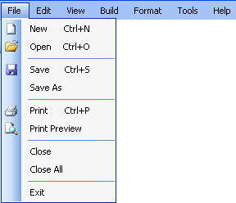

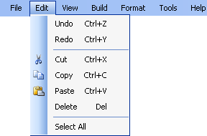

10.2 How To Use Process Control Studio
Now we are going to explain briefly in easy steps how to use PCS to design a process and how to monitor and control it.
    - Check the minimum requirements.
    - Insert the Setup CD intro your CD Drive.
    - Double click setup.exe to install PCS.
    - Click on your Start Menu: Start> Programs> Process Control Studio.
PCS has now started.
    - Choose New Process to create a new process design layout.
This Wizard will help you to create a new process easily.
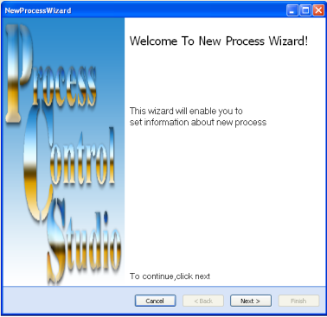

5.1-After clicking Next, enter Process Name ,ID ,IP and Process Description.
This information will be stored in database and will be use during communication.
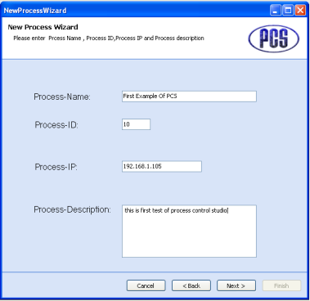
5.2- Click Next and if there is no duplicated information you will be told that the process file has been created and this information is stored in database
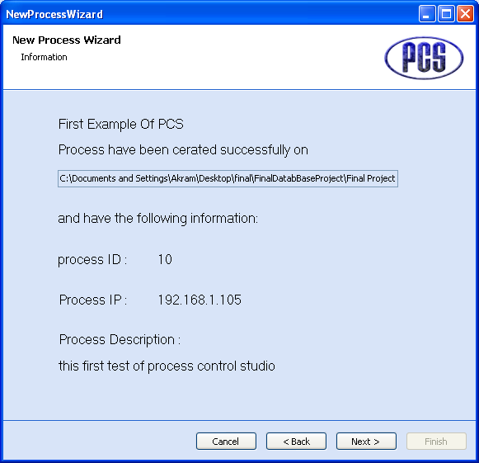
5.3- Click Next and Finish to start your work.
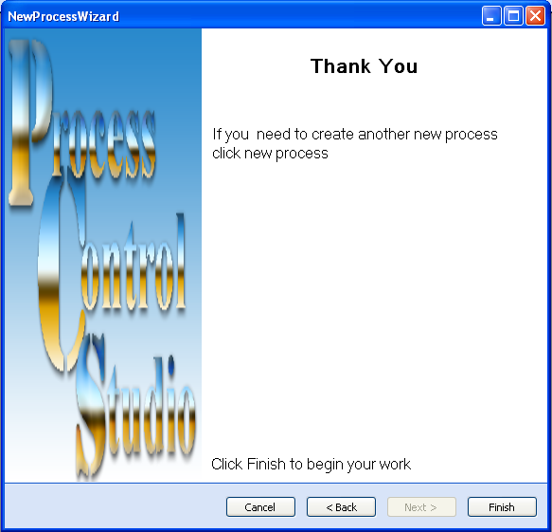
6-Start dropping the required process components from the PCS Toolbox on to the design area. As an example here, we select two tanks, a pump and a valve.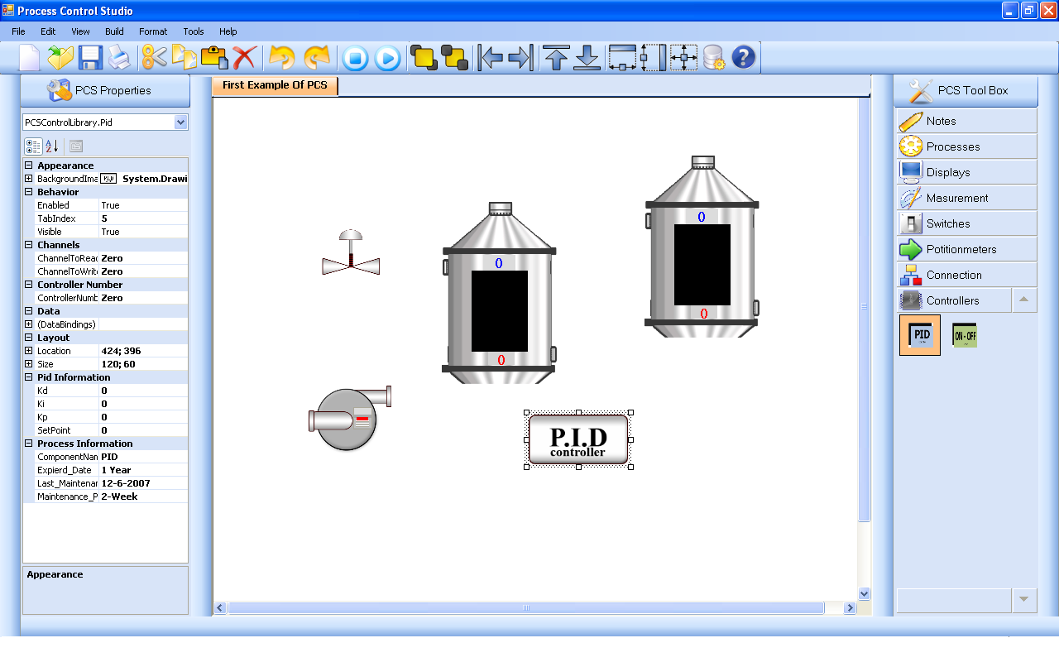
7- Connect the process components together using pipes, wires and connectors. 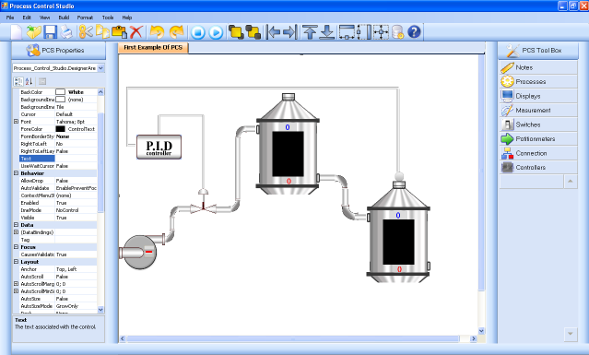
8- Set the process properties, values and parameters using the property grid.
9- Set the channels for each input or output signal for each component.
10- After your finish click Save to save the design with its initial values and properties so it can be easy for you to open it again.
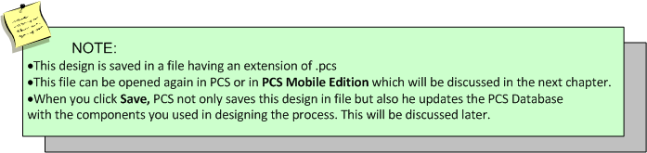
10- Finally click Run from PCS Tool bar to start acting run mode

10.3 Process Control Studio Examples

Example 1: Alarming System
This example tell us about the alarming system that Process Control Studio provides.
PCS provides three type of alarms:
- Sound
- Flash and notification window
- SMS using SMS through a web server
Also any event of alarming occurs will be stored in PCS database to help control engineers to know which process has a large number of alarms.
Looking at the previous example, we can set the properties of a tank as follows to enable the alarming system:
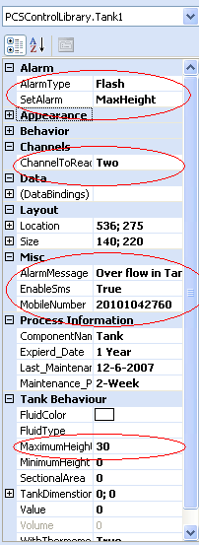
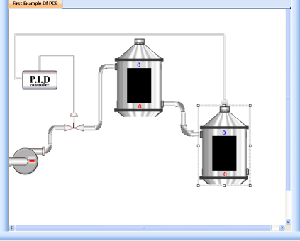
If the value of the tank becomes more than 30, which is the maximum height of the tank, the alarming system will notify the control engineer.
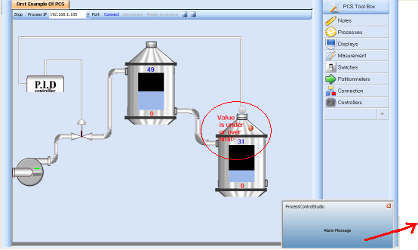
By: Flash , SMS and a notification window will appear which means that this alarm has been stored in PCS Database.

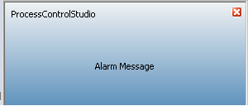

Example 2 :ON –OFF Controller
- Run Process Control Studio
- Start New Process
- Start dragging and dropping the required components and connect them using pipes and connectors.
- Start setting the properties of each component.
- Set ON-OFF Controller on channel Two for Channel to Read and channel Six for Channel to Write.
- Set Neutral Zone to 20 , and Set Point to 80
- Set tank on channel Two for Channel to Read.
- Set valve on channel Six for Channel to Write.
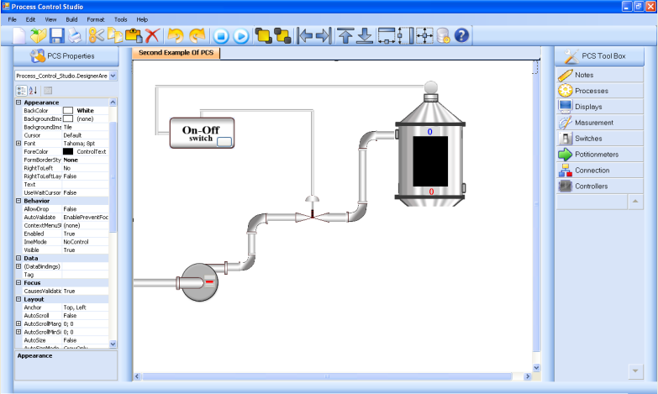
- Click Save to save the design.
- Click Run to start the run mode.
- From run mode toolbar, choose the IP address of the local controller then click Connect.

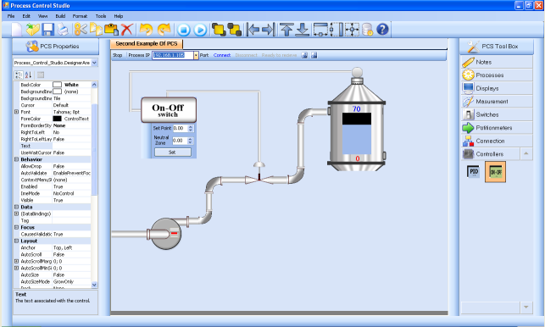
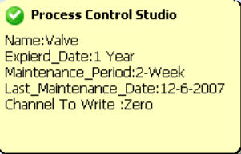
- While you are in run mode and monitoring your process, you can take a control action by changing the ON-OFF controller Set Point or Neutral Zone by right clicking on ON-OFF controller.
- After your finish your work click Disconnect and Stop.
- If you move the mouse over any component during run mode, a tool tip appears displaying information about this component such as maintenance date, maintenance period, expired date, channel to read and channel to write. This information will help the control engineer to know the history of each component and take the necessary actions.
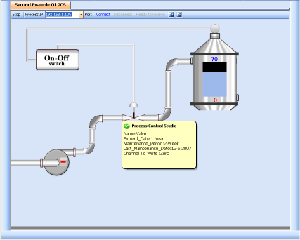

10.4 Process Control Studio Database
Process control Studio Database consists of six tables:
  - Process Information Table
  - Component History Table
  - Stock Details Table
  - Supplier Details Table
  - Make Order Table
  - Alarm History Table

Tables Description
Process Information Table :
- This table stores information about processes like Process Name, ID, IP and Process Description.
- This information is stored into the database after you click Finish in New Process Wizard.
- This information will be useful in connecting with the local controller.
- Database must not have duplicated Process Name or Process ID. PCS will refused storing information duplication occurs, telling you that you must check that there is no duplication in Process Name or ID.
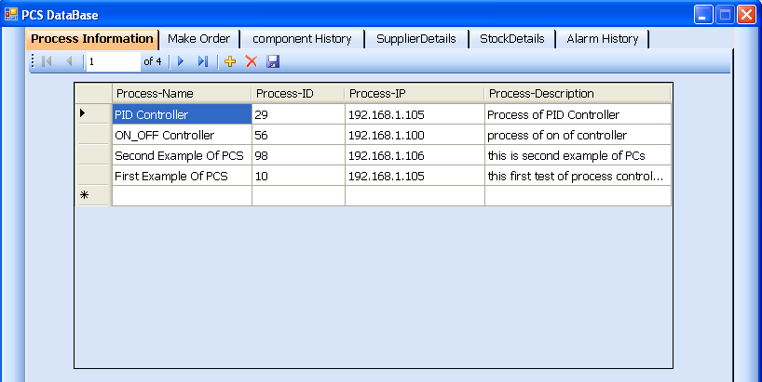

Component History Table:
- It stores information about each component in process such as Name, Maintenance Date, Maintenance Period and Expired Date.
- This information is stored into the database once you click Save.
- At the first when you design the process you should enter the Maintenance Period and Expired Date.
- It is very useful to know the states of each process and generating reports.
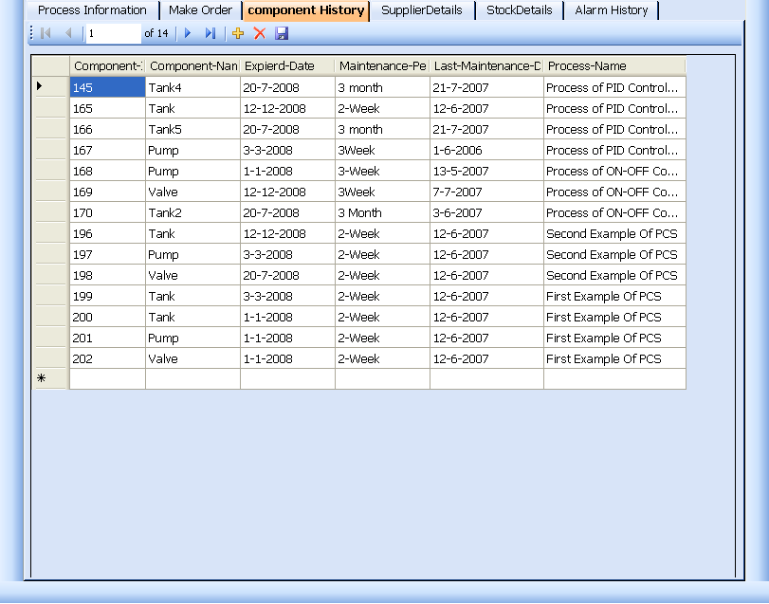

Stock Details Table:
- It stores information about inventory and this information will help control engineers to know which component has a shortage and how to make order for it.
- This information is stored into the database when you click Save Process at the first time only.
- For example, if you design a process that contains two tanks and two valves and a pump, this means that process at real-time contains these components and you take them from the store when you click Save.
PCS will deduce stock of tanks by value two and also valves and pumps.
- The two fields: Max Number of Units Allowed and Min Number of Units Allowed, are used to know which component have shortage:
- Max Number of Units Allowed tells the maximum number of this component to be in the stock when an order is made.
- Min Number of Units Allowed tells the minimum number of this component that PCS will notify the control engineer to make order if the units in the stock of this component becomes less than Min Number of Units Allowed.
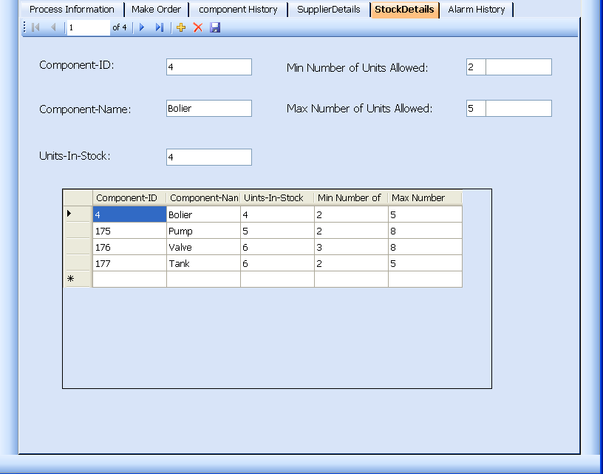

Make Order Table:
- It stores information about components which have previously faced shortages and had orders made for it.
- As explained previously, if any shortage happens PCS will notify the control engineer to make an order by displaying a notification window. If the engineer clicks on it, PCS database form will open to show which component is facing shortage.
- Quantity ordered = Max Number of Units Allowed - Units in Stock
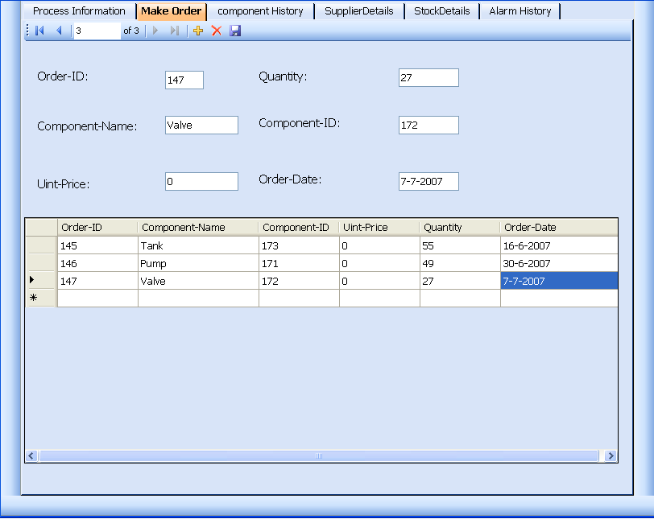
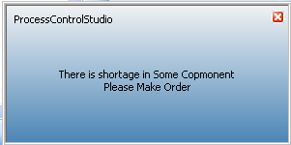
- This is the notification window which will appear when a shortage happens in some component. If you click on it, PCS Database will open to show you which component has shortage and therefore make order for it.

Supplier Details Table:
- It stores information about suppliers which supply the plants components.
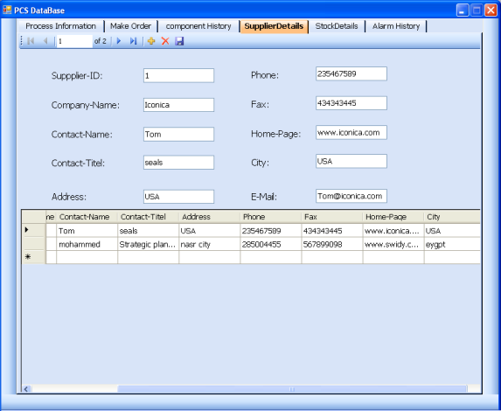

Alarming History Table:
- It stores information about alarming such as
  - Alarm Type
  - Alarm Date
  - Process Name
- It is updated in real time when an alarm occurs due to a certain process.
    - This information will be useful in generating reports to show the status of each process.
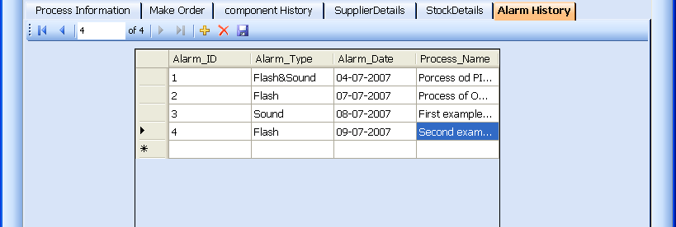

10.5 Process Control Studio Users
PCS has two types of user s (default users):
    - Control Engineer
    - Operator

1- Control Engineering can perform the following jobs:
      - Designing the process.
      - Setting the properties of each component in the process.
      - Add and delete users form the database.
      - All jobs can done by operator user.

2- Operator can perform the following jobs:
- Load process form .pcs file.
- Monitor and take control actions.

When you run PCS, you will be asked about your user type, as shown:
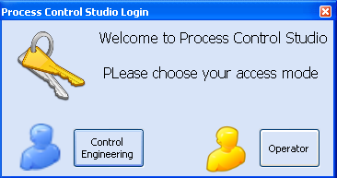

If you are a control engineering If you are an operator
